Population table with prefilled data- design

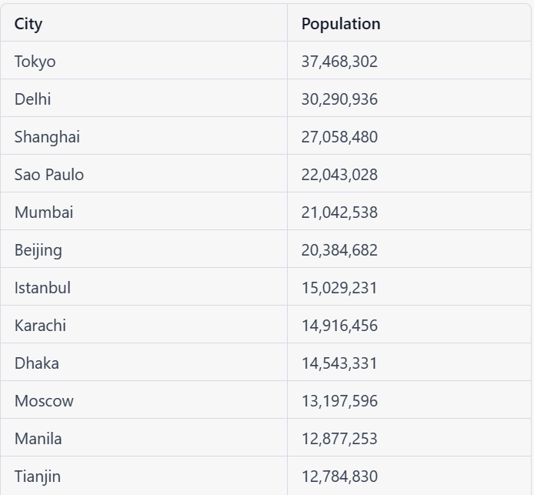

City info page – prefilled data added on table.

